1) The part of the electromagnetic spectrum represented by this graph is mostly
Select one:
a. ultraviolet
b. microwave
c. visible light
d. infrared

2) The brightest line in the spectrum would have a wavelength of Answer 550nm.

Use this info to answer numbers 3 and 4
It shows the energy use per person as a function of GDP per capita (how much income the people have). The scale is logarithmic, so the 1971 and 2010 values for Vietnam are shown for you. Note that the size of the bubbles is proportional to the population of the countries.
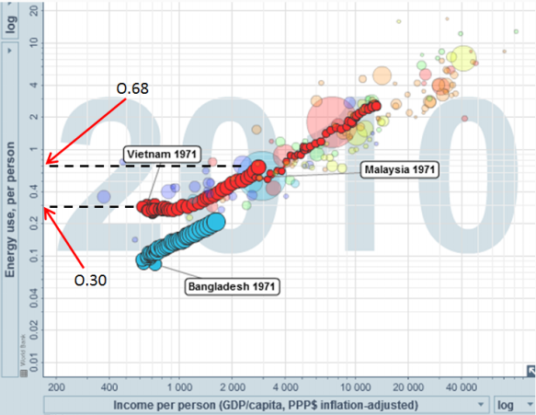

3) The graph shows the energy use per capita from 1971 until 2010. A conclusion that can be drawn from this graph is
Select one:
a. As countries get richer their people use less energy.
b. Countries with fewer people do better than countries with more people.
c. Vietnamese people use more energy per capita than Bangladeshi people do.
d. Increased energy use in a country causes the country to become richer.

4) Vietnam’s energy use per person, from 1971 to 2010 increased by Answer 0.380%.
Round and record your answer to three significant digits, include a decimal if needed.

Use this image to answer question 5
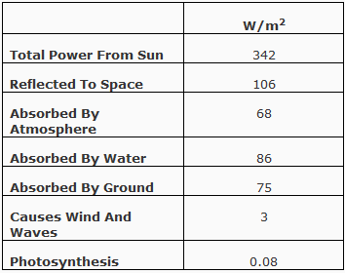
5) The solar energy that causes wind and waves is Answer 0.08 times the solar energy absorbed for photosynthesis?
Round and record your answer to the nearest whole number.

Use this picture to answer question 6
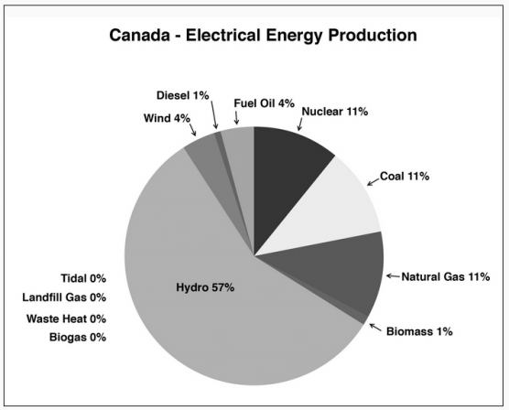

6) The majority of electrical energy in Canada is produced by ______ energy.
Select one:
a. chemical
b. gravitational
c. nuclear
d. thermal

Use this to answer number 7

Human technology is based largely upon energy transformations. Some of this energy is in the form of

1. Chemical Energy
2. Phase change
3. Nuclear energy

7) Listing these energy types from lowest to highest magnitude of energy produced per kilogram is abc. The values of a, b, and c are
Phase change, nuclear change and chemical change

Use this to answer number 8 and 9
This map shows the location of the dams that have been built on the Columbia River Basin. The size of the circles represents the height of the dams. The color of the circles represents the owners of the dams. These dams produce over 35 000 MW of power in total.
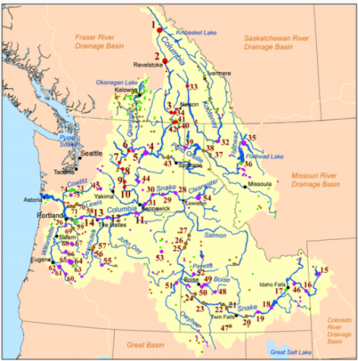

8) The area covered by this map would suggest that the power density of hydroelectricity is __i__. A major environmental impact of these dams is __ii__.

The statements above are compelted correctly by the information in row ____.
Select one:
a. high; ecological disturbance upstream of the dam
b. high; emission of greenhouse gases
c. low; ecological disturbance upstream of the dam
d. low; emission of greenhouse gases
9) In order for this river basin to remain sustainable with this much hydroelectric power generation installed, the area must be __i__ and __ii__.

The statement above is completed correctly by the information in row ____.
Select one:
a. humid; relatively flat
b. humid; mountainous
c. arid; relatively flat
d. arid; mountainous

Use this to answer number 10
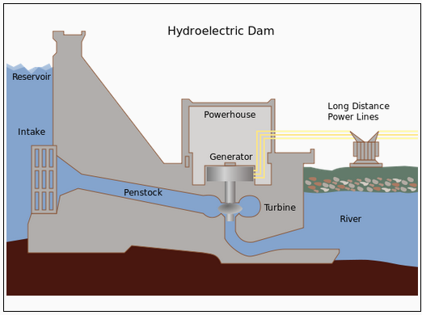

10) During a prolonged drought a hydroelectric station’s power output would __i__ because __ii__.

The statement above is completed correctly by the information in row ____.
Select one:
a. remain the same; the length of the reservoir doesn't change much
b. decrease; the length of the reservoir doesn't change much
c. remain the same; the depth of the reservoir goes down
d. decrease; the depth of the reservoir goes down

11) The total power generation from tidal stations is less than 1% of the power generated by hydroelectric dams. The reason for this is
Select one:
a. Tidal stations produce more greenhouse gases.
b. Hydroelectric dams take up less space than tidal stations.
c. Hydroelectric dams can be made larger than tidal stations.
d. Tidal stations have fewer good locations then hydroelectric dams.

The process of forming a compound can be exothermic or endothermic. The compounds from the following list that are formed by endothermic processes include a, b, and c.
Use this to answer number 12
12) The compounds a, b, and c, ordered from lowest heat of formation to highest heat of formation are numbered:____,_____,_____

13) The substance on your table of Standard Heats of Formation that requires the largest energy input in order to form is
Select one:
a. sucrose
b. hydrogen sulfide
c. nitrogen dioxide
d. ethyne

Answer number 14 and 15 using the graph below

14) The best analysis of the data in order to calculate the heat of combustion is use the __i__ of the water to find the heat absorbed by the water. __ii__ the molar heat of combustion of fuel.

The statements above are completed correctly by the information in row ____.
Select one:
a. highest temperature; The result is
b. highest temperature; Dividing by the amount of fuel gives
c. temperature change; The result is
d. temperature change; Dividing by the amount of fuel gives

15) Any values calculated from Hess’s law are predicted values for heats of combustion. The predicted value for sucrose is 1586 kJ/mol. When doing a lab, the students found the heat of combustion of sucrose was 1350 kJ/mol. Their percent error was Answer 15%.

16) Chemical analysis of heats of combustion give values of over 40 MJ/kg for alkane fuels (methane, ethane, propane, …). This is a __i__ energy density which makes these fuels __ii__ to use for energy production.

The statements above are completed correctly by the information in row ____.
Select one:
a. high; easy
b. high; hard
c. low; easy
d. low; hard

Use the graph to answer number 17
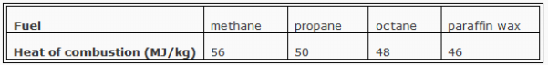
17) If equal amounts of each of these fuels are ignited, they burn more slowly as the length of the carbon chains increases. Methane (natural gas) is explosive, and paraffin wax (over 20 carbons on its chain) burns slowly. We can say that as the carbon chains increase in length, the energy density __i__ and the power density __ii__.

The statements above are completed correctly by the information in row ____.
Select one:
a. increases; increases
b. increases; decreases
c. decreases; increases
d. decreases; decreases

18) In order to extract the bitumen from the oil sands it is necessary to heat the bitumen so it will flow to the surface. This process will __i__ and __ii__ compared to extracting conventional oil.
The statemens above are completed correctly by the information in row ____.
Select one:
a. increase efficiency; increase greenhouse gas emissions
b. increase efficiency; increase acid deposition emissions
c. use extra fossil fuel; increase greenhouse gas emissions
d. use extra fossil fuel; increase acid deposition emissions

Use the graph to answer number 19
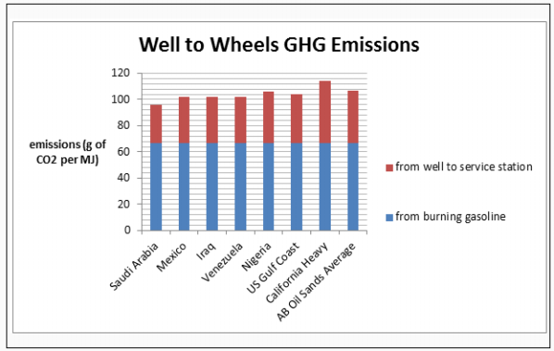

19) We can conclude from this graph that the amount of CO2 emissions __i__ the method of extraction and refining of petroleum. In addition, the burning of the gasoline is __ii__ of the total process.

The statements above are completed correctly by the information in row ____.
Select one:
a. depends upon; the smaller part
b. doesn't depend upon; the smaller part
c. depends upon; the larger part
d. doesn't depend upon; the larger part

20) Petroleum deposits that are close to the surface and flow easily are called __i__deposits. A major drawback to these deposits is that __ii__.
The statements above are completed correctly by the information in row ____.
Select one:
a. conventional; they are more expensive to develop
b. conventional; there are fewer of them left to discover
c. non-conventional; they are more expensive to develop
d. non-conventional; there are fewer of them left to discover

21) Coal combustion has been cleaned up with the removal of __i__ from the coal. Coal fired plants still emit the most __ii__ of all the generation methods.

The statements above are completed correctly by the information in row ____.
Select one:
a. sulfur; carbon dioxide
b. sulfur; water vapour
c. oxygen; carbon dioxide
d. oxygen; water vapour

